CPRE HERTFORDSHIRE AWARDS 2022 NOMINATION FORM

Please email the completed form to office@cpreherts.org.uk or post hard copies to the address above.

CLOSING DATE: Tuesday 31 May 2022

CPRE Hertfordshire Awards recognise and celebrate inspirational activities which
- Connect people with the countryside and their local green spaces
- Promote rural life and ensure that communities can thrive
- Improve or protect the environment

Our 'Made in Herts' award will recognise excellence in sustainable farming and local foods, products using local materials, or traditional craftspeople and artists, in particular working in rural areas and with rural themes.

Nominees might be volunteer-based projects and community groups, individuals or small businesses. We hope to make an award for an outstanding project or activity run by or on behalf of young people (up to the age of 21) in the categories above.

Your Name:
Email:

Telephone no:

How did you find out about CPRE Hertfordshire Awards?

I would like to receive information about joining CPRE Hertfordshire (please tick box)

Name of project, business or individual being nominated:

Address:

Email:

Telephone number:

If this is an event, please tell us what date it is being held:

Social Media contact details (website, Facebook, Twitter etc.):

Name of owner or co-ordinator of nominated project or business:

Email:

Telephone number:

Please tell us about the nominated project, business or individual. Tell us what they have achieved and why you feel they should receive an award:

Photographs
Nominees may submit digital photographs in support of the nomination: this is optional. At a later date, CPRE Hertfordshire will contact nominees to obtain photos and/or to arrange for the judges to take photos themselves. Photo permissions will be confirmed at that time.

Personal Data
We hold and manage personal data in accordance with the Data Protection Act 2018. We won’t share, sell or swap your information with other organisations for their own marketing purposes. You can read our privacy policy on our website for more information: https://www.cpreherts.org.uk/privacy-policy/

The judges’ decision is final.
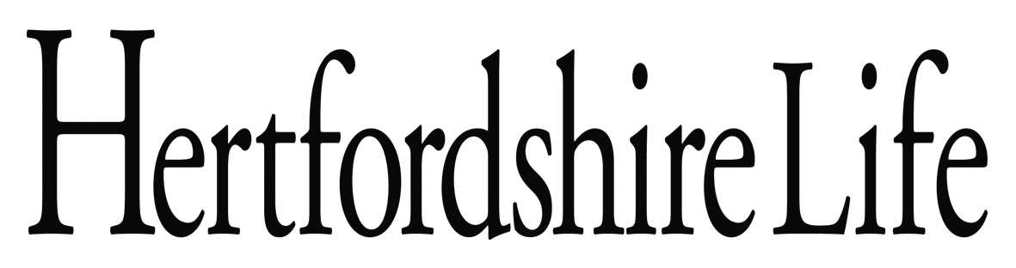
The CPRE Hertfordshire Awards are supported by
Hertfordshire County Council and Hertfordshire Life

